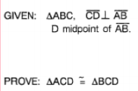DO NOW:

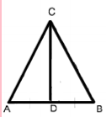

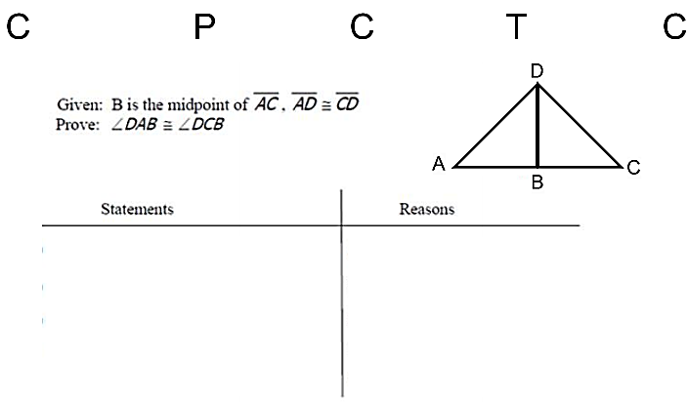

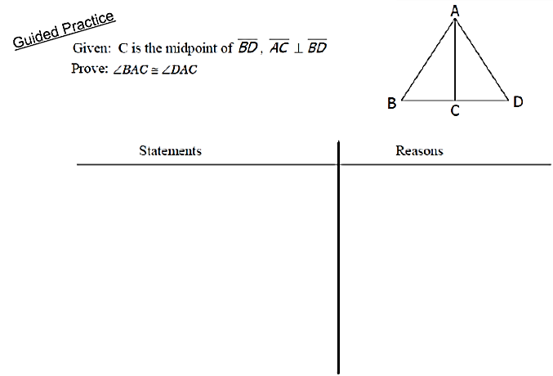

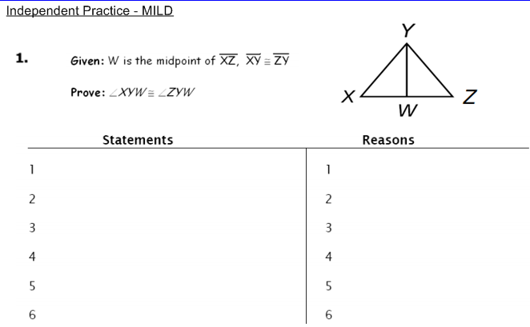

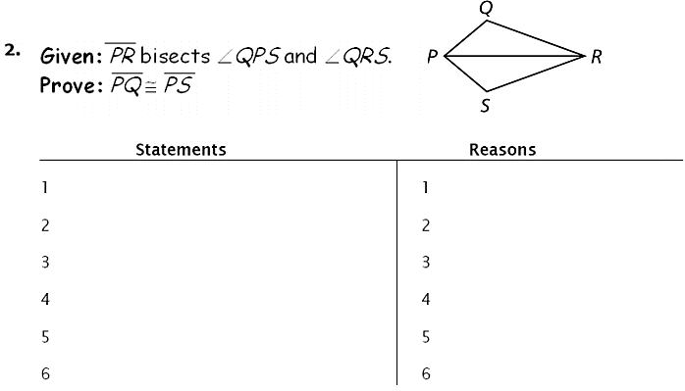

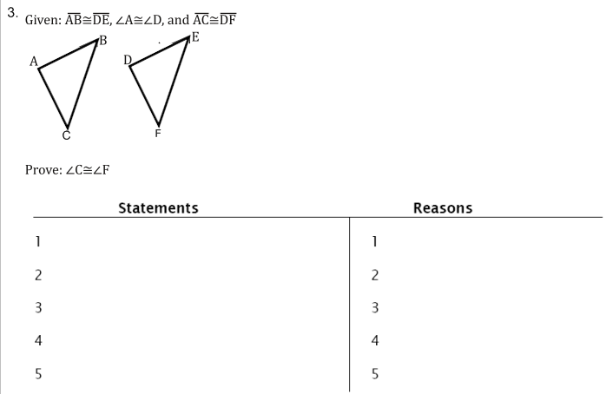

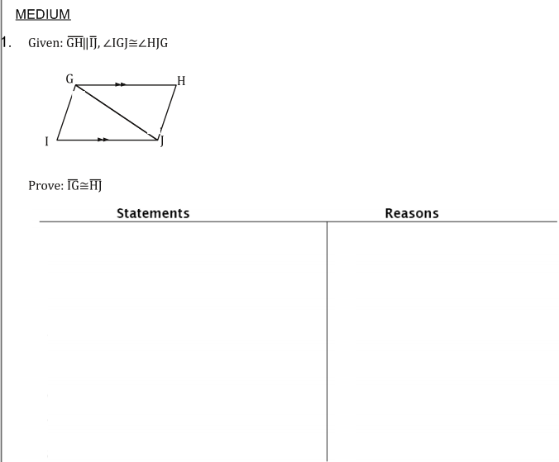

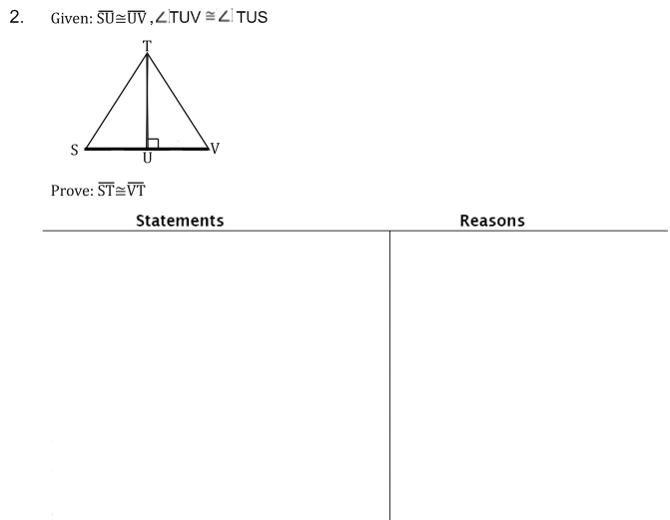

3.11 HW: Corresponding Parts of Congruent Triangles are Congruent (CPCTC)*Front & Back!*

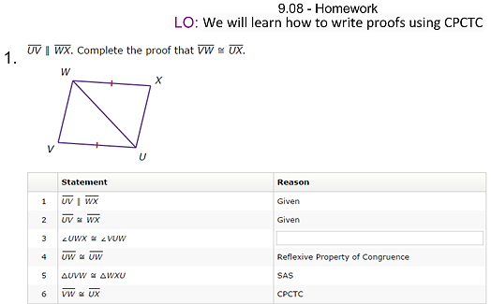

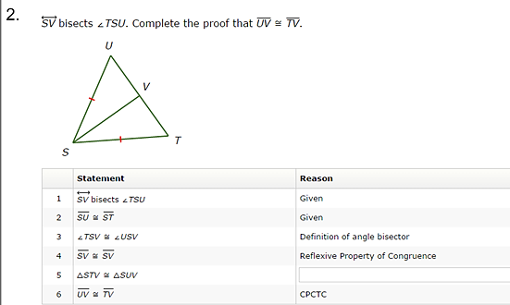

**3.**

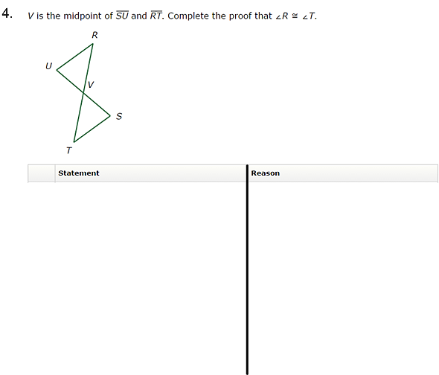

**Reflection**

1. My current grade in Pupil Path in Geometry is: ________
2. Something I am doing well in Geometry class is…

**__________________________________________________________________________________________________________________________________________________________________________**

1. Something I could do better in Geometry class is…

**__________________________________________________________________________________________________________________________________________________________________________**

1. In Geometry class, from Ms. Guarnaccia and my classmates, I need more…

**_____________________________________________________________________________________**

1. Geometry class, from Ms. Guarnaccia and my classmates, I need less…

**_____________________________________________________________________________________**